Databases
IT Management
Jack Barnet

Contents
Introduction 2
Example statements 2
SQL Statements 3
1.1 From table 1 (family_members) above, write SQL statements to select columns name and num_books_read? Please, display the table as appropriate 3
1.2 From table 1 (family_members) above, write SQL statements to select rows where species is human 3
Tables 4
Queries 4
Forms 5
Part B Question 2 5
Table 1 5
Table 2 5
Foreign key 6
Form 6
Query 7
Query 2 7
Part B Question 3 7
Table 1 Design view 7
Table 1 Data sheet view 8
Table 2 Data sheet view 8
Table 2 Design view 8
Query 1 Design view & datasheet view 9
Query 2 Design view & datasheet view 10
Form Design view and form view 11

Introduction
SQL stands for Structured Query Language which is the language used in databases. The language used is made of statements and allows information to be held using tables and shows a language to look up these tables (query) and other procedures, functions, views. Most database applications use this language such as SQL Server, Oracle, PostgreSQL, MySQL all use this language for handling data. Structured Query Language you can edit, insert, delete, update, create, or change the database. Edgar Frank Codd worked for IBM when he invented the relational database in the 1970s then later Donald Chamberlin and Raymond Boyce designed SQL to manipulate data it was originally called SEQUEL but due to a trademark issue, it was changed to SQL.

Example statements
All statements used with the help of W3Schools are referenced below.
The following statement will select all records in the customer table | SELECT * FROM Customers;
The following statement will select records from the first and second columns on the customer’s table | SELECT column1, column2  FROM Customers;
This statement will follow the order sort the country in alphabetical order | SELECT * FROM USER  ORDER BY Country ASC;
This deletes the Users name Jack Barnet from the User table | DELETE FROM USER WHERE USERNAME='Jack Barnet';
The update statement is used to modify the existing records that are in the table | UPDATE table_name  SET column1 = value1, column2 = value2, ...  WHERE condition;
The between statement is for two different values | SELECT column_name(s)  FROM table_name  WHERE column_name BETWEEN value1 AND value2;
This command is for declaring a primary key this is needed in every database because this is an indication of a unique code there are no duplicate numbers of the primary key  example – Order number  Customer ID | CREATE TABLE Persons (  ID int NOT NULL,  LastName varchar(255) NOT NULL,  FirstName varchar(255),  Age int,  PRIMARY KEY (ID)  );
This statement groups the rows with the same values into summary rows | SELECT column_name(s)  FROM table_name  WHERE condition  GROUP BY column_name(s)  ORDER BY column_name(s);

SQL Statements

1.1 From table 1 (family_members) above, write SQL statements to select columns name and num_books_read? Please, display the table as appropriate
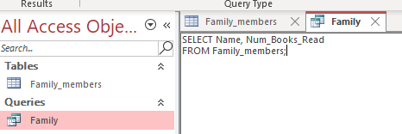
These are the statements I used to get the results shown below

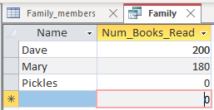
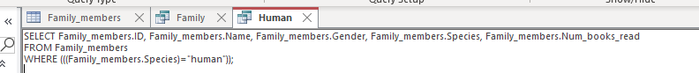
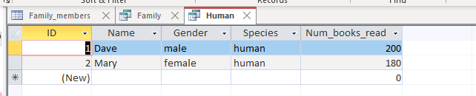
These are the results I got from the statements above
2. These are is the statements I used to get the results for just humans under species category
SELECT Family_members.ID, Family_members.Name, Family_members.Gender, Family_members.Species, Family_members.Num_books_read
FROM Family_members
WHERE (((Family_members.Species)="human"));

1.2 From table 1 (family_members) above, write SQL statements to select rows where species is human

Tables

Tables are database object that holds all the information in the database. It is logically organized by rows and columns just like a spreadsheet. There are different types of rows one requires to be called a primary key this is where the key is unique so no other can have the same this is often a number that scales and will never repeat example Order ID, Customer ID, Employee Number. Tables are required in databases because this shows all the information, and this is the main part of the database. (Appendix A)

Primary key | This is the most common key this is required in every database. A primary key is where no two rows can be the same it has to be unique, and no two rows can have a primary key there can only be one. The primary key must have data in the field it cannot be blank or null.
Compound key | This is where you have two unique records that are recognized to a record. These records might not be unique in the database them self’s but combined they are a combination of composite keys that become unique. Example Order No and Product ID combined would equivalate a Compound key
Foreign key | Foreign keys are used in databases that want to link two together it acts as a cross-reference between two tables. The main point of a foreign key is to link the two tables together and to have two different instances of an entity where they work together. (Appendix B)

Queries

A database query Is a search that can be completed on the table to retrieve certain information so it can be retrieved from a table and be separated. A query is a way of requesting information from a database and it can search for a user who has worked somewhere within a certain timeframe or all employees working at the business for more than 10 years. Queries are a really useful part of databasing and SQL since they can help users find the information, they are requiring about the specific topic they are needing. This is where SQL comes from which stands for Structured query language which is where information is searched. (Appendix C)

Forms
A form is another database object that can be used to display, edit add, move and display information from a table or a query. A form can be used to control access data such as what information is displayed. Users can insert information that is needed such as all their details name, surname, height, weight, favourite colour and so much more. A form has more of a user interface so it’s easier for people to use.

Part B Question 2

Table 1
This is the table I created with a few of the employees from Interplex the date they started and also what town or city they stay in.
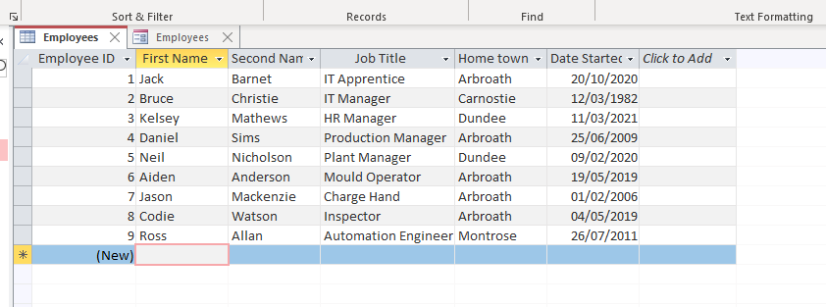

Table 2
This is the second table I have made to show how many hours the workers have worked in one week and also how many employees have got how many holidays they have left.
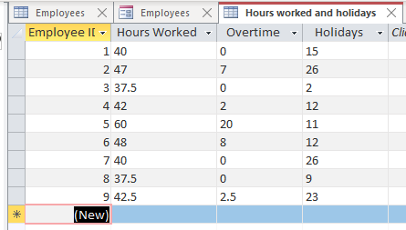

Foreign key
This is showing the relationships between the two tables using a foreign key on the second table to see what employee number follows and is shown for the other table.
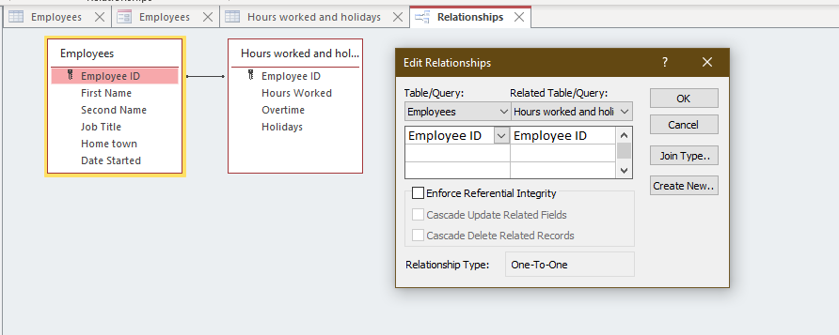

Form
This is the form I have created using the form wizard where more users can add new employees if required
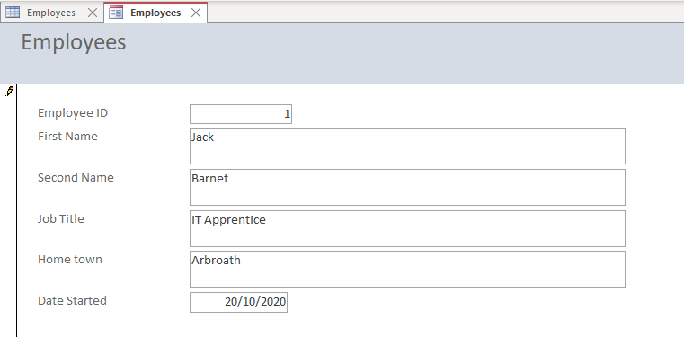

Query
This was a query I had completed to see what employees are from the town of Montrose.
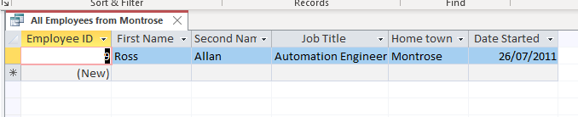

Query 2
This is the query I had completed to see all employees with 15 or more holidays
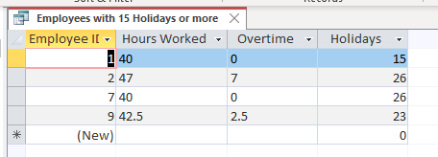

Part B Question 3

I have attached all the design views and also the datasheet views required for this database also continues on the views required for the queries and also form.

Table 1 Design view
This is the design view for the employee’s table this includes where you can see the primary key, I have put it in the description, so it is clear.
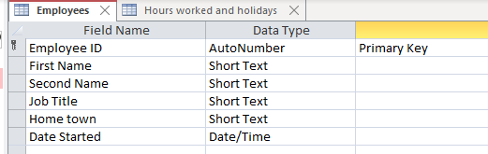

Table 1 Data sheet view
This is the data sheet view
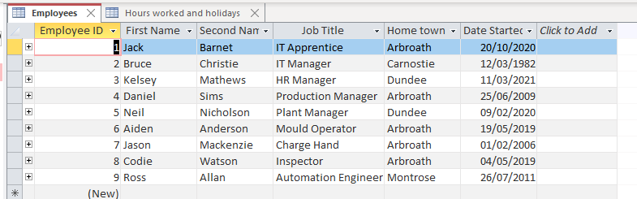

Table 2 Data sheet view
This is the datasheet view I have attached for the hours worked and holiday table. Showing all the employee’s numbers with the hours they have worked for the week and also their holidays.
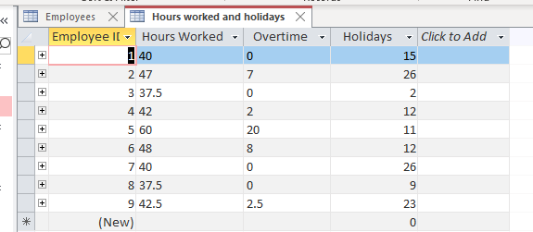

Table 2 Design view
This is the design view so I can show the hours worked and holidays the employees still have I have also added description on them all so I can show what one is the foreign key and also the reasoning behind them not just being a number.

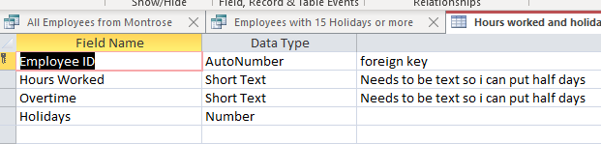

Query 1 Design view & datasheet view
This is the design view and the data sheet view for all the employees with the hometown as Montrose
This is the SQL code required to find the information of who is from Montrose
SELECT Employees.[Employee ID], Employees.[First Name], Employees.[Second Name], Employees.[Job Title], Employees.[Home town], Employees.[Date Started]
FROM Employees
WHERE (((Employees.[Home town])=" Montrose "));

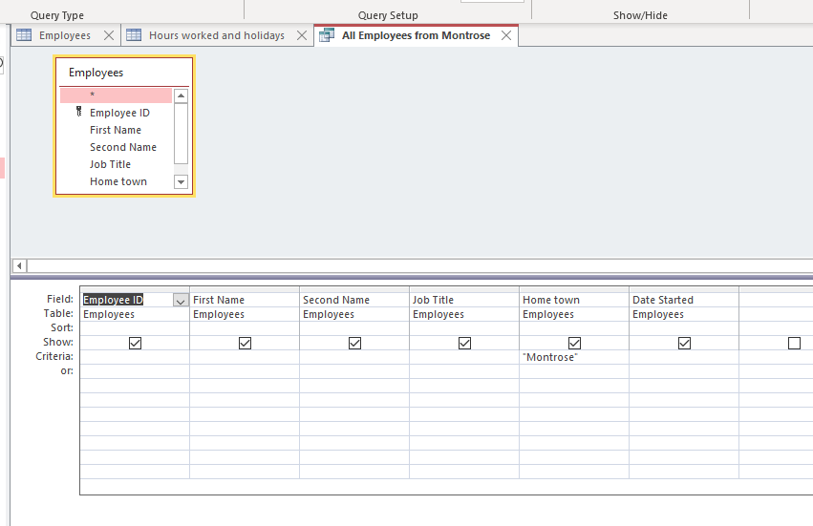

Query 2 Design view & datasheet view
This is the design view and datasheet view for the query for employees with more than 15 holidays.
This is the SQL code required for the information of who’s got more than 15 holidays
SELECT [Hours worked and holidays].[Employee ID], [Hours worked and holidays].[Hours Worked], [Hours worked and holidays].Overtime, [Hours worked and holidays].Holidays
FROM [Hours worked and holidays]
WHERE ((([Hours worked and holidays].Holidays)>=15));

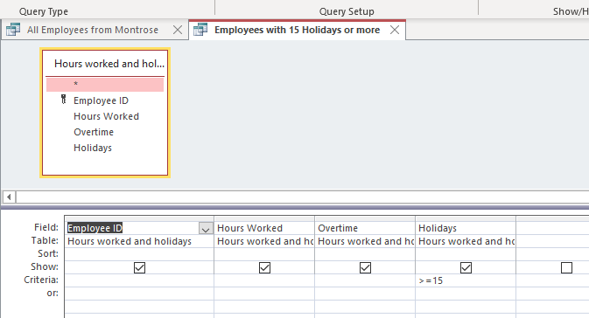

Form Design view and form view
This is the design view for the form I have created this is where the form can be edited to put on other information or move them around you can also add a footer or a header if required which means it can be signed or extra information can be added if it’s required
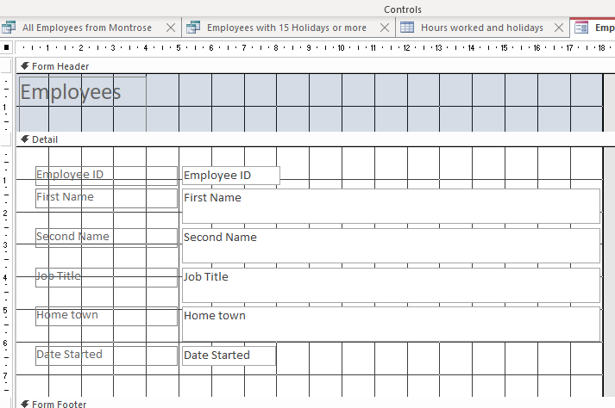

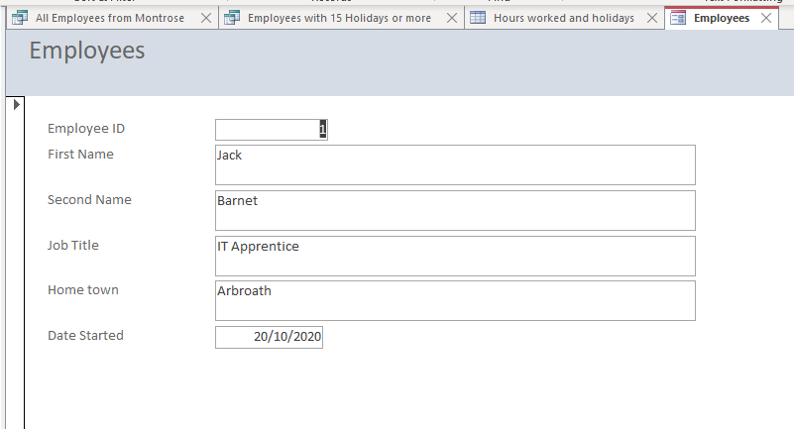

References
Docs.microsoft.com. 2021. Tables - SQL Server. [online] Available at: <https://docs.microsoft.com/en-us/sql/relational-databases/tables/tables?view=sql-server-ver15> [Accessed 28 November 2021].
W3schools.com. 2021. W3Schools Free Online Web Tutorials. [online] Available at: <https://www.w3schools.com/default.asp> [Accessed 28 November 2021].
Upgrad. 2021. Types of keys. [online] Available at: <https://www.upgrad.com/blog/types-of-keys-in-dbms/> [Accessed 28 November 2021].

